Appendix A. Engineering Analysis

# Finite Element Analysis

## Armor Plate

The armor plate of the robot that protects the internal components was loaded with a 100 lbf force applied to a 1 in diameter circle in the middle of the least supported area of the plate. This represents a large force from another robot attack and tests to see if it would damage internal components. 100 lbf was settled on as it would be a large force for a 25-pound robot to be able to apply during an attack and the location was chosen to cause the maximum deflection.

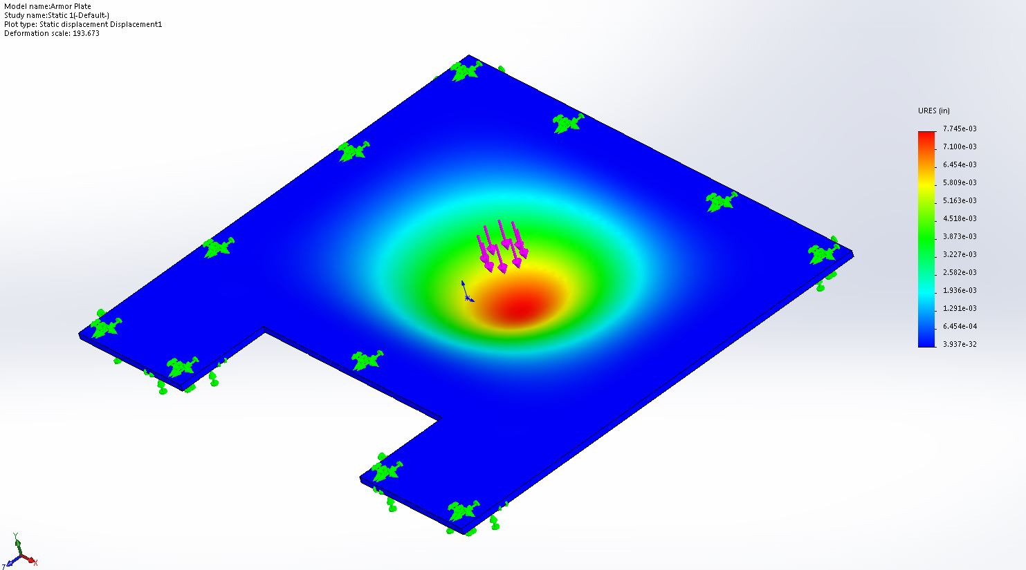

Figure : displacement of Armor Plate due to 100-pound force

The model was constrained in all degrees of freedom at the screw holes that hold it onto the robot, and on a 1 inch perimeter where the frame would be supporting the plate. As Figure 1 shows, the maximum deflection is 7.745e-03 inches, so this deflection does not endanger any internal components. 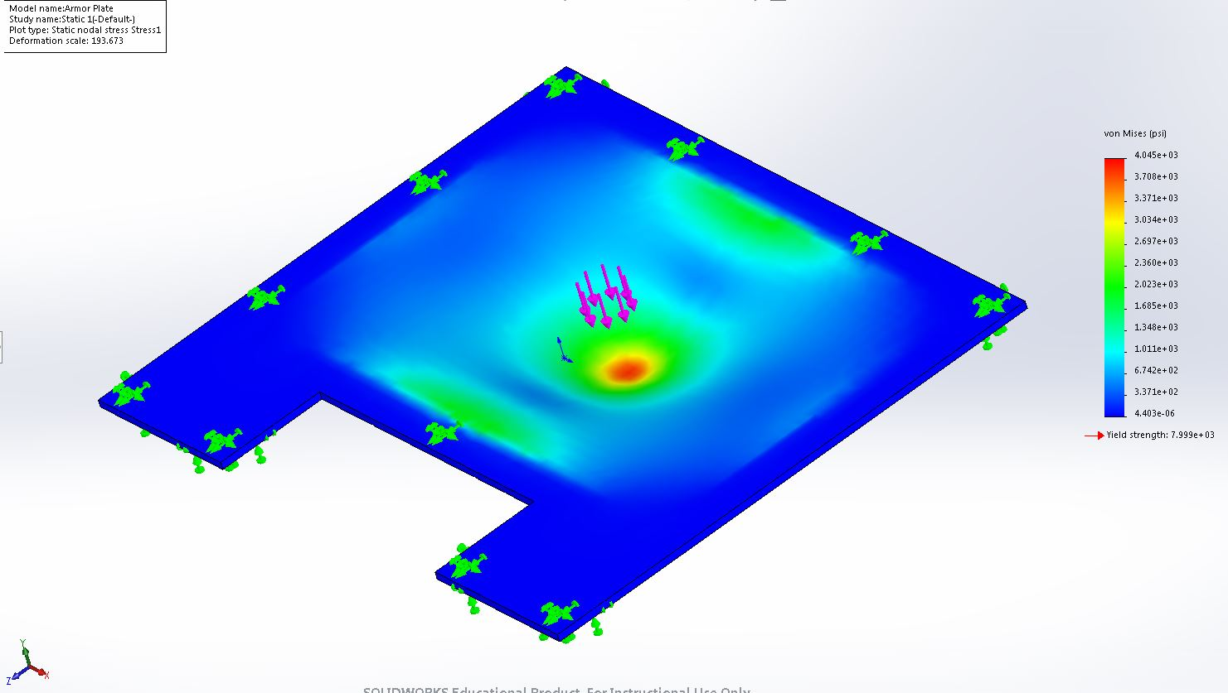

Figure : stress of Armor Plate due to 100-pound force

The maximum stress caused by this force is 4.045 ksi as shown in Figure 2. This gives the plate a factor of safety of 1.98 against permanently deforming from this force. This armor will do an adequate job of protecting the internal components of the robot.

## Frame

The frame provides the primary structure of the robot so its integrity is of great importance.

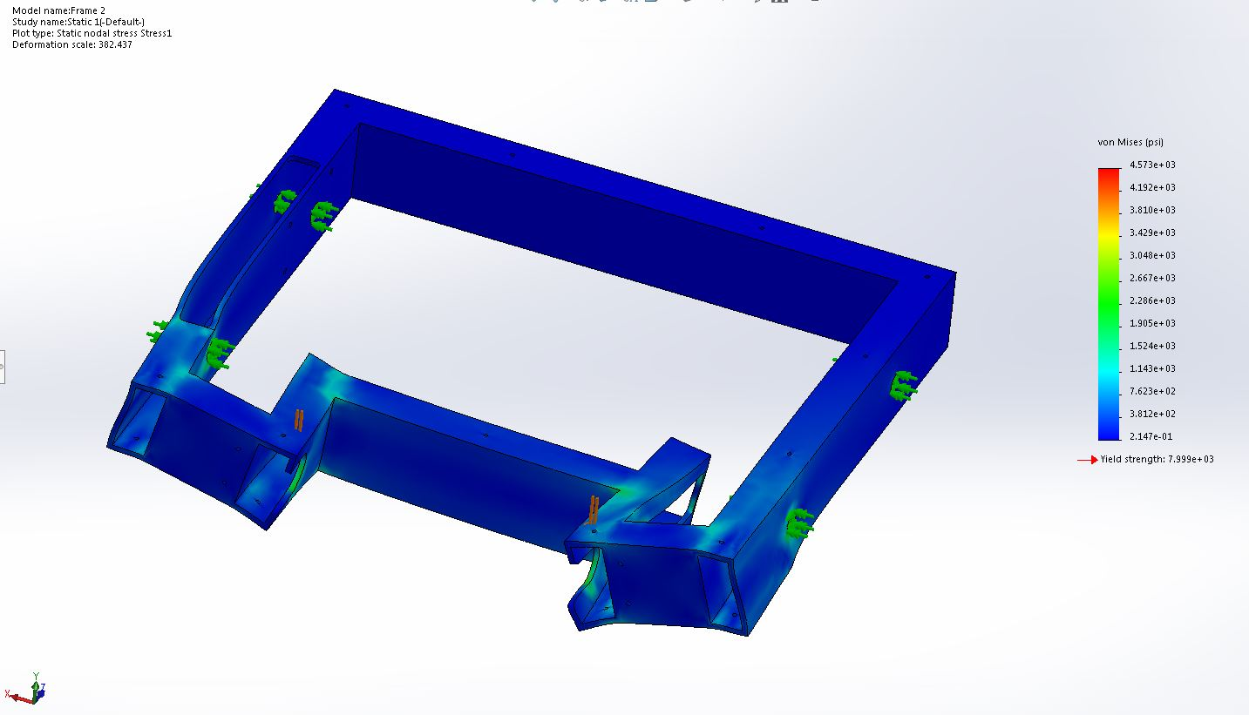

Figure : Stress on Frame under 200lbf force at weapon connection

To ensure the frame could withstand the force of the weapon hitting an opponent, the frame was loaded with a 100-pound force on each side where the weapon attaches to the frame, as shown in Figure 3. The axle holes were anchored in all degrees of freedom except rotation. The maximum stress appears directly below the applied forces, but drops off quickly. This is likely a result of the ideal application of the force along a line rather than over an area, causing the local stress to be more concentrated. A factor of 1.75 against yielding under these conditions means that the use of the weapon is unlikely to damage the frame.

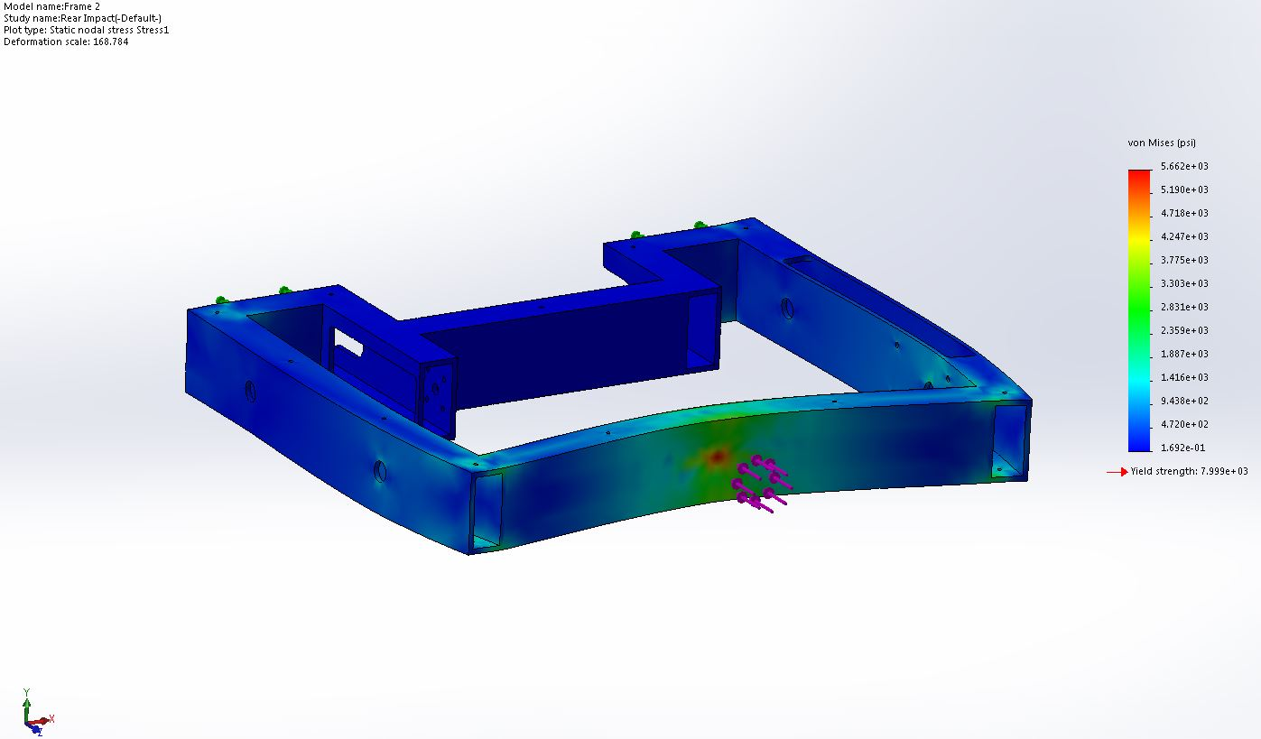

Figure : stress in Frame due to 100lbf force applied at rear

Analysis was also done on the frame under a 100lbf load applied to a 1 inch circle in the center of the rear of the frame to account for impacts to the back of the robot, as shown in Figure 4. The front faces were anchored in all degrees of freedom. This was chosen because the rear of the frame is its most exposed part of the structure and therefore the most likely to get hit. It is also the longest unsupported span of any piece of the frame. The analysis shows that the frame resists permanent deformation from this force by a factor of safety of 1.41. This portion of the frame is strong enough to adequately protect the robot.

## “Roller” Weapon

The robot’s weapon will be under large stresses as it impacts other robots and obstacles. As such, a large load of 300lbf was applied to one of its outer bars tangent to the weapon’s axis of rotation to simulate a large strike.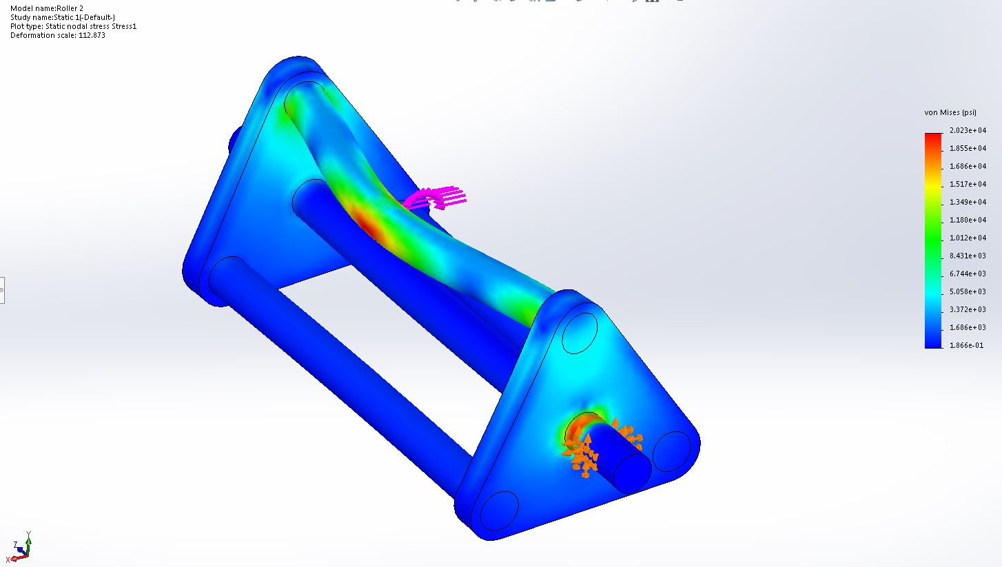

Figure : Stress on Roller under 300-pound force at center of bar

In this model, 300 lbf was applies to the canter of one of the bars of the weapon and the center axle was constrained in all degreed of freedom at the points at which it attaches to the bearings. The yield strength of the steel bars is 26 ksi, giving the piece a factor of safety of 1.29 at this loading. Additionally, since in operation there is nothing attached to the roller capable of providing the 450 in-lbf (the applied motor torque at stall is 97.2 oz-in) of torque needed to resist motion under this load, the high stress area on the main axle is expected to be much lower than the conditions of this analysis predict.

# Electronics

## Weapon Acceleration

The weapon is meant to reach a top speed of 1600 RPM. Based on what data was available about our chosen motor, it provided an average torque of 55.51 oz-in and had an average speed of 800 rpm. This converts to a torque of 0.392 N*m and an angular speed of 83.776 rad/s. The average power was calculated:

$$P_{ave}=0.392 N*m*83.776\frac{rad}{s}=32.84 W$$

The kinetic energy was calculated from its operating speed of 1600 RPM and the moment of inertia about the axle provided by SolidWorks of 806 kg*mm^2.

$$KE=\frac{1}{2}*806 kg*mm^{2}*{10}^{-6}*\left(1600 RPM*\frac{1 min}{60 sec}*2*π\right)=11.3136 J$$

And so, the estimated time to reach speed is

$$t=\frac{KE}{P_{ave}}=0.3445 sec$$

## Power and Amperage

The power budget of the electrical systems was calculated using the length of a match and the stall amperage of the three motors. The motor stall amperage is 20A each, for a total of 60A. The raspberry pi takes a 230mA current under heavy computational load and the motor controllers did not list the amperage needed to run the control circuit. These were deemed to be negligible compared to the motors. Each round is 3 minutes, or 0.05 hours.

$$P=60A*0.05hr=3Ah$$

Our battery provides 4.2Ah. This calculation is a worst-case scenario. The robot is not expected to require full stall amperage for the majority of the round and, though no power curve is given, the no-load amperage of each motor is as low as 0.51A. The power supply was designed for the worst case, as the exact power used each round will vary widely depending on what happened in that round.